2024 MSSC ANNUAL MEMBERSHIP APPLICATION
Three ways to return your membership form:
Mail to: Mt. Si Senior Center, PO Box 806, North Bend WA 98045
Hand deliver to: 411 Main Ave S, North Bend WA 98045
Online at: www.mtsiseniorcenter.org
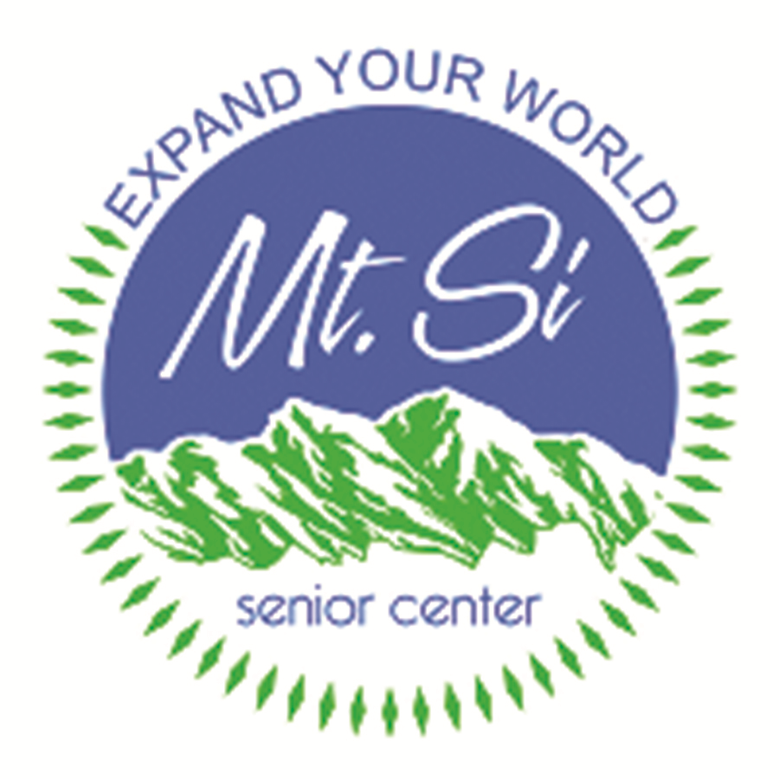

Please activate or renew my annual MSSC membership
Annual Membership (Year runs 2/1/24 – 1/31/25) *
☐ One year individual membership $40
☐ One year couple membership $70
(Includes Spouse or Domestic Partner)
Subtotal: $_______
* 2024 Membership dues paid prior to 2/1/24 will confer membership for the entire period through 1/31/25.
Donation to the Mt. Si Senior Center
☐ In addition to my membership, I would like to support the Center’s mission with a donation of:
☐ $100 ☐ $75 ☐ $50 ☐ $25
Subtotal: $_______
☐ I would like more information about how to make a planned gift to the Center
☐ I have remembered the Center in my will or trust
Payment Information
Total Amount Enclosed: $____________
To Be Paid By: ☐ Cash ☐ Check ☐ Credit Card
Credit Card payments accepted in person or online only. Visit us at www.mtsiseniorcenter.org to buy your membership online.
I understand there are no refunds ______ (please initial)
Want to Stay Informed?
Would you like to receive information about the center on activities and programs via email?
Emails? ☐ Yes ☐ No
Office use only (please print clearly):
Received on: ___________ Received By: _________
Amount Paid: __________ Check #: _____________
- 2024 Membership card provided

Membership for older adults aged 50+.
Member Information (Please Print)
Name: _____________________________________
Street Address: _____________________________
Unit or Apt: ________________________________
Mailing Address: ____________________________
(If different)
City/State/Zip: _____________________________
Home Phone: ______________________________
Cell Phone: ________________________________
Email: ____________________________________
Birth Date: _________________________________
Gender:☐ Male ☐ Female ☐ Other ☐ Prefer Not to Say
For Couple Memberships
Spouse/Partner: ______________________________
Cell Phone: _________________________________
Email: ___________________________________
Birth Date: __________________________________
Gender:☐ Male ☐ Female ☐ Other ☐ Prefer Not to Say
Emergency Contact Information
Name: ___________________________________
Relationship: ______________________________
Cell Phone: _______________________________
Email: ____________________________________
How did you hear about Membership?
☐ Letter ☐ Visit to Center ☐ Friend
Would you like to volunteer at MSSC?
☐ Yes ☐ No
Like Mt. Si Senior Center on Facebook

