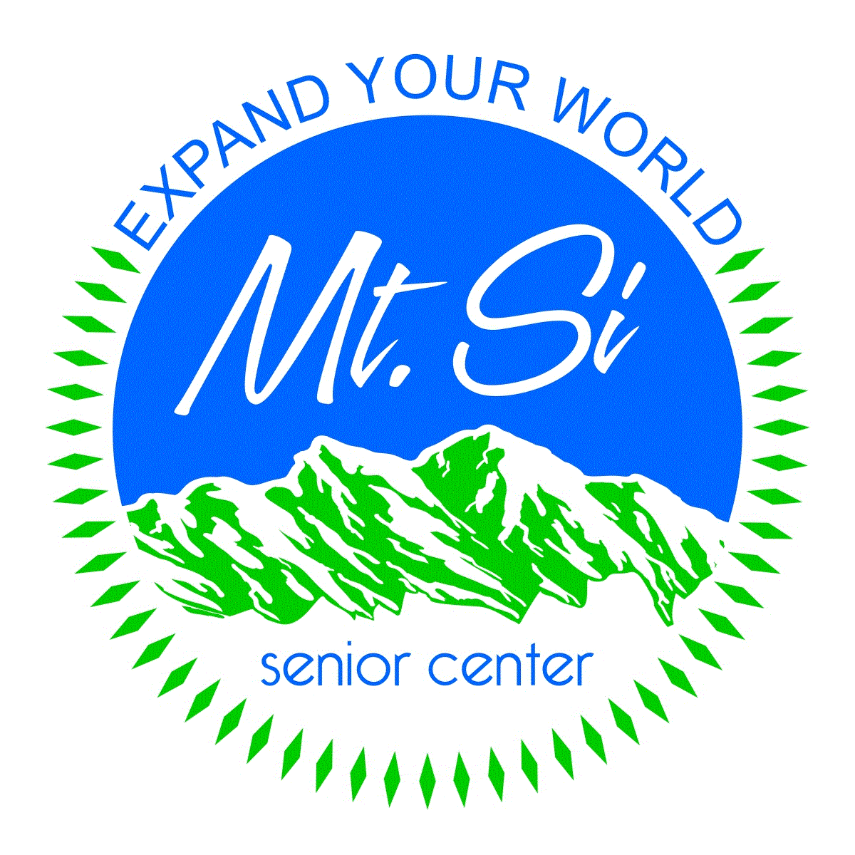
Office Use Only

Date Received __________

Data Entry Date _________

Data Entry Initials _______
Mt. Si Senior Center
Client Information Form 2021
We ask anyone using the Center to provide us with their information so that we can better serve them with a variety of programs, services, or assistance suited for their needs or circumstances. Finally, to protect our Center, we require clients to review and sign off on all waivers.

Client Information
First Name M.I.
Nickname
Last Name
Suffix: Jr. Sr. Other________
Date of Birth
Home Phone
Cell Phone
Email
Address Line 1
Address Line 2
PO Box City
State Zip Code
County where I live
King County Other _________________
I live (pick one):
within the city limits
outside the city limits
(unincorporated county area)
Are you a current MSSC volunteer? Yes No
Are you interested in volunteering? Yes No

Emergency Contact Information
Please provide contact information for those who we should notify in case of an emergency. Your emergency contact may include a family member or friend.
Emergency Contact Name
Relationship
Home Phone
Cell Phone
Work Phone
Email
Address Line 1
PO Box City
State Zip Code

Name of Spouse
(if not listed as emergency contact above):

Doctor’s Name
Doctor’s Phone
Want to Stay Informed? Please check the boxes below if you would like to receive information on activities and programs via email:
Emails: □ Yes □ No

Demographic Information
We ask for demographic information because much of our funding is based on the categories of people we serve. Your personal information will be kept confidential.

1. Gender Male Female Other | 10. Yearly Household Income:  One Person Household - $23,250 or less - $23,251 to $38,750 - $38,751 to $61,800 - $61,801 or more Two Person Household - $26,600 or less - $26,601 to $44,300 - $44,301 to $70,600 - $70,601 or more  Three Person Household - $29,900 or less - $29,901 to $49,850 - $49,851 to $79,450 - $79,450 or more Four Person Household - $33,200 or less - $33,201 to $55,350 - $55,351 to $88,250 - $88,251 or more
2. Ethnicity Hispanic/Latino(a)
Non-Hispanic/Latino(a)
3. Race
American Indian or Alaska Native White or Caucasian
Asian, Asian-American Multi-Racial
Black, African-American, Other African
Native Hawaiian or Pacific Islander
Other Race
4. I am a refugee or immigrant in the US: Yes No
5. My primary language is:  English Other __________  I have limited English: Yes No | 11. Employment Status:  - Full-time permanent Seeking employment  - Part-time permanent Not seeking employment  - Seasonal – Day employment Retired
6. My Marital Status is:  Married/Partnered Single Widowed | 12. Sexual Orientation  Unknown Lesbian  Bisexual Questioning  Gay Other  Heterosexual Prefer not to say
8. Head of Household:  - I am the head of the household  - I am not the head of the household | 13. Do you have any allergies? Yes No  If yes, please list:
14. Do you have a disability (check all that apply):
Hearing impairment
Vision impairment
Cognitive impairment
Developmental disability
Physical impairment
Mobility issues
I use a wheelchair I use a walker or cane
Chronic illness or pain
Mental Disability Sensory Disability
Other _______________________________
No disability
Unknown

15. Is there anything you would like us to know about you that would increase your participation in or access to the programs and services at the Center?

9. Military/Veteran Status (check all that apply):
I have served in the military (past or present)
I did not serve in the military
I am the spouse/partner of veteran
If you would like to be honored on Veterans Day, please provide details of your service including:
Branch of Service: ___________________________
Rank upon Discharge: _________________________
Years of Service ___________ through ___________

Waivers, Agreements and Signature

Last Name: _________________________ First Name: ___________________________

Please initial next to each of the five waivers. | Initials
Photography: I grant to MSSC its representatives and employees the right to take photographs of me and my property in connection with use or support of the senior center. I authorize MSSC, its assigns and transferees, to use and publish the same in print and/or electronically. I agree that MSSC may use such photographs of me with or without my name and for any lawful purpose, including for example such purposes as publicity, illustration, advertising, and Web content.  Name Use: I authorize MSSC to use my name in print, in our newsletter and/or in displays related to MSSC activities and advertising.  Release from Liability: Yes, I release MSSC and all its agents from any liability for any accident, injury or damages of any kind to persons or property that might occur while participating in MSSC activities.  Code of Conduct: I understand my behavior, while here, reflects on the organization and affects the ability of MSSC to deliver services to all seniors. I agree to refrain from behavior that: infringes on the rights of others; results in the destruction of property or equipment; violates any federal, state, county or city laws or ordinances; is threatening, aggressive, violent; or which may be taken as racial, religious or sexual harassment or is discourteous towards others. Possession or use of alcohol (except for during special events for which an alcohol license has been secured is not permitted). Possession or use of controlled substances is forbidden. As a member of the senior center, I understand that every effort is needed to make this a warm, positive and safe environment. The code of conduct is posted in the Center and is available upon request.  Fitness classes: I acknowledge that if I choose to participate in a MSSC physical education class, I do so voluntarily. I hereby assume the risk for any injuries I may sustain during the pursuit of this activity while on the premises, and hereby release and forever discharge the instructors and the senior center from any actions, suites, damages, claims or judgements that may result from any personal or health injury I may sustain while so engaged. I understand that certain health hazards may exist in participation and hereby agree to accept any or all risks of said injury. Furthermore, I agree that I, my heirs, distributors, legal guardians, representatives and assignees will make no claims against, pursue suits attaching the property or prosecute the senior center or volunteer instructors for injury or damage resulting from my participation. I have carefully read this agreement and fully understand its contents. I am aware that this is a release of liability and a contract between myself and Mt. Si Senior Center, and I sign this of my own free will.  Signature _______________________________________Date _________________________ | ________  _______  _______  _______  ______

